**Assignment #6: Orbit Report**

Warning

Please do not attempt this assignment until AFTER your first lecture on Angular. It can be tempting to dive right in, but Angular is a broad topic and you want to wait to start until you have time to go over the requirements in class.

There are thousands of satellites orbiting the earth. You are tasked with creating a searchable, sortable table of satellites. For the purposes of this assignment, **satellite** will be defined as any object purposefully placed into orbit.

1. **Satellites**: Table with each row being a satellite.
2. **Counts:** Count of all satellites and count for each type of satellite.
3. **Search form:** Text entered limits results based on matches. Pressing enter or clicking button triggers search.
4. **Sortable columns:** The name and type column headers can be clicked, which will sort the table using that property.

**Setup**

1. Create a new project on Github named orbit-report.
2. Clone that repo to your computer.
3. Create a new Angular project in the cloned repo folder using this command.
   * $ ng new --skip-git orbit-report
   * It's important to include the --skip-git because we don't want Angular to create a git repo for us.
   * Prompt answers: No Routing, Use CSS
4. Commit and push your changes to Github.

**Requirements**

As you accomplish each task, be sure to commit and push your changes before moving on to the next item.

**1) Define and Create Satellites**

In JavaScript, TypeScript, and Angular projects you can create classes to represent entities in the project. For this project you need to create a class named Satellite to represent, you guessed it, a satellite. The Satellite class needs to define the properties needed to accurately represent a satellite.

1. In terminal go to the orbit-report folder.
2. Create a class with command $ ng g class Satellite.
3. Notice that the new file orbit-report/src/app/satellite.ts was created.
4. Add these properties to the Satellite class in satellite.ts:

name: string;

orbitType: string;

type: string;

operational: boolean;

launchDate: string;

1. Add a constructor to Satellite class.
   * Constructor signature should be constructor(name: string, type: string, launchDate: string, orbitType: string, operational: boolean)
   * You need to assign the class properties in the constructor.

Now we need to use the Satellite class to create an initial array of Satellite objects.

1. Define an array named sourceList in app.component.ts.
   * sourceList: Satellite[];
   * For this to compile, you must add import { Satellite } from './satellite'; to the top of the file.
2. In the constructor in app.component.ts set sourceList to be an array of Satellite objects.

constructor() {

this.sourceList = [

new Satellite("SiriusXM", "Communication", "2009-03-21", "LOW", true),

new Satellite("Cat Scanner", "Imaging", "2012-01-05", "LOW", true),

new Satellite("Weber Grill", "Space Debris", "1996-03-25", "HIGH", false),

new Satellite("GPS 938", "Positioning", "2001-11-01", "HIGH", true),

new Satellite("ISS", "Space Station", "1998-11-20", "LOW", true),

];

}

1. In terminal run ng serve
2. View the app in your browser. At this point you should see the default Angular starter page. If you don't, check the build output and browser console for any errors.

**2) Create Orbit List Component**

Now that you have an array of Satellite objects, you can display them. To do that, you are going to need to create a new component named orbit-list.

1. Create orbit-list component using $ ng g component orbit-list in the app folder.
2. Replace the contents of app.component.html with just one line of code, <app-orbit-list></app-orbit-list>.
3. View the app in your browser. You should see: orbit-list works!

**3) Pass in Satellites to Orbit List Component**

The orbit-list component's job is to show a list of satellites. Remember you declared an array of Satellite objects in app.component.ts named sourceList. In order to pass that array into the orbit-list, you need to learn a new Angular feature named [input properties](https://angular.io/guide/component-interaction#pass-data-from-parent-to-child-with-input-binding). For the purpose of this feature, the term input refers to data being sent *into* the component. Angular input properties are NOT related to HTML input elements.

Currently app.component.html uses the orbit-list component like so:

<app-orbit-list></app-orbit-list>

To pass in the sourceList array to the orbit-list component you need to learn new syntax. Notice the code [satellites]="sourceList". The [satellites] declares that you are setting a property on the orbit-list component named satellites. ="sourceList declares that the value of the satellites property will be the value of the sourceList array.

<app-orbit-list [satellites]="sourceList"></app-orbit-list>

1. Add [satellites]="sourceList" to <app-orbit-list></app-orbit-list> in app.component.html.
   * <app-orbit-list [satellites]="sourceList"></app-orbit-list>
2. View the app in your browser.
   * You should NOT see the message "orbit-list worked!". Why?
3. Open developer tools in your browser and look at the JavaScript console.

You should see the below error message telling you that the orbit-list component does NOT have a satellites property. Note only the relevant message text has been included below.

Error: Template parse errors:

Can't bind to 'satellites' since it isn't a known property of 'app-orbit-list'.

1. If 'app-orbit-list' is an Angular component and it has 'satellites' input, then verify that it is part of this module.

To solve this issue, you need to declare in orbit-list.component.ts that the orbit-list component has an input property named satellites.

1. Add the code below to just before the constructor in orbit-list.component.ts.
   * @Input() satellites: Satellite[];

The @Input() is special Angular syntax that declares that satellites is a property that will be passed into the component via <app-orbit-list [satellites]="sourceList"></app-orbit-list>.

1. Update the require statements to import Input and Satellite
   * import { Component, OnInit, Input } from '@angular/core';
   * import { Satellite } from '../satellite';
2. View the app in your browser. You should see: orbit-list works!
   * You still don't have satellites showing yet. That is the next step.

**4) Display Table of Satellites**

Now that orbit-list has a satellites property that is an array of Satellite objects, you can use that array to build an HTML table with each row being a different satellite.

1. In orbit-list.component.html use``*ngFor`` to loop over the satellites. The HTML table you build should look like the following.

|  |  |
| --- | --- |
| 1  2  3  4  5  6  7  8  9  10  11 | <h3>Orbit Report</h3>  <table>  <tr class="header-row">  <th class="sortable">Name</th>  <th class="sortable">Type</th>  <th>Operational</th>  <th>Orbit Type</th>  <th>Launch Date</th>  </tr>  <!-- TODO: put <tr *ngFor=""></tr> here -->  </table> |

Next you need to include CSS that will make your table and application look a little nicer.

1. Copy the entire contents of the [example orbit-list-component.css](https://gist.github.com/welzie/5247f5ac36e973903cd5202af50932e6) and put it into your orbit-list-component.css.
2. Copy the entire contents of the [example app.component.css](https://gist.github.com/welzie/5247f5ac36e973903cd5202af50932e6) and put it into your app.component.css.
3. Copy the <style> tag from the [example index.html](https://gist.github.com/welzie/5247f5ac36e973903cd5202af50932e6) and paste it into the <head> of your index.html.
   * Only add in the <style>, do NOT remove any other HTML from your index.html.
4. View the app in your browser. You should see a table like the below.

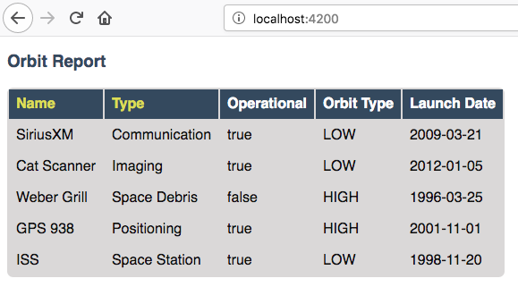

Example of application at this point. Don't worry if yours doesn't have a heading of "Orbit Report" yet, you can add that later.

**5) Fetch Satellite Data**

So far you have used an array declared in app.component.ts as the source of data to display. Your next task is to switch to using a fetch that retrieves json data from a server.

1. Replace your constructor in AppComponent with the code below.
2. Implement the three features mentioned in the TODO: comments.

constructor() {

this.sourceList = [];

let satellitesUrl = 'https://api.myjson.com/bins/ccxv5';

window.fetch(satellitesUrl).then(function(response) {

response.json().then(function(data) {

let fetchedSatellites = data.satellites;

// TODO: loop over satellites

// TODO: create a Satellite object using new Satellite(fetchedSatellites[i].name, fetchedSatellites[i].type, fetchedSatellites[i].launchDate, fetchedSatellites[i].orbitType, fetchedSatellites[i].operational);

// TODO: add the new Satellite object to sourceList using: this.sourceList.push(satellite);

}.bind(this));

}.bind(this));

}

Note

Explaining the .bind(this) syntax is beyond the scope of this book, but is crucial for this.sourceList.push(satellite) to work properly.

1. View the app in your browser. Your table should look similar to:

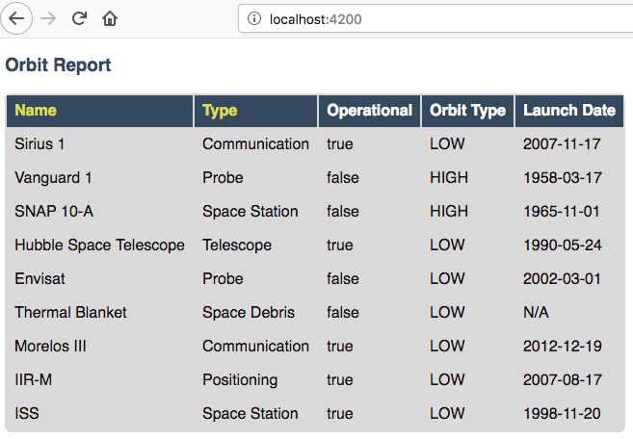

Example of application after switching to fetched data.

**6) Highlight Space Debris**

You need to make it easier to spot dangerous space debris in the list. You will accomplish this by adding an Angular attribute directive.

1. Add a shouldShowWarning method to the Satellite class.
   * shouldShowWarning returns a boolean and has no parameters.
   * shouldShowWarning returns true if the satellite type is 'Space Debris', returns false otherwise.
2. Use shouldShowWarning to add the warning CSS class to the <td> containing the satellite's type.
   * For guidance refer to the section on [changing styles with attribute directives](https://education.launchcode.org/intro-to-professional-web-dev/chapters/angular-lsn3/attribute-directives.html#changing-styles-with-booleans)

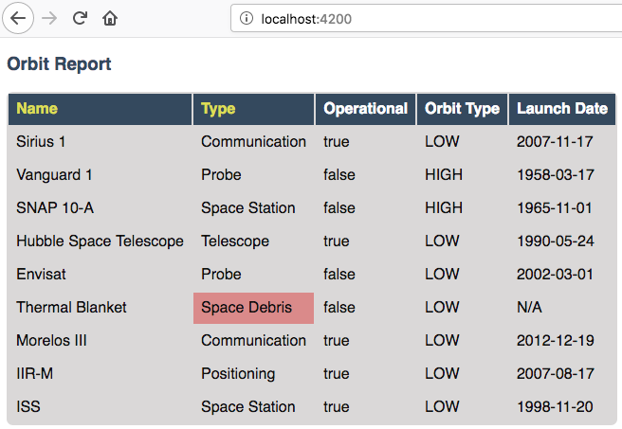

Example of warning style adding a red background to Space Debris type.

**7) Sorting**

Sorting is a useful feature for any table. When the "Name" heading is clicked sort the table by the name property. Also when the "Type" heading is clicked, the table should display sorted by the type property.

1. Add an Angular click handler that calls sort('name') to the Name <th> element.
   * Note that the sorting feature will not work until you have completed step 3.
2. Add an Angular click handler that calls sort('type') to the Type <th> element.
3. Add a sort method to the OrbitListComponent class.
   * The sorting method has been provided below.
   * For an example of sort working, see [Orbit Report Demo](https://education.launchcode.org/intro-to-professional-web-dev/assignments/orbit-report.html#orbit-report-demo).

Note

The provided sort method contains a new usage of the array.sort method. Previously in the book you used array.sort without passing it a function, see [sort function examples](https://education.launchcode.org/intro-to-professional-web-dev/appendices/array-method-examples/sort-examples.html#sort-examples). This usage of array.sort uses a compare function, which allows you to control how the objects in the array are sorted. A compare function is needed to sort the array of Satellite objects, because JavaScript does not know how to sort objects, JavaScript needs you to tell it which Satellite object should go before another Satellite object. For more details about the compare function see [MDN description of sort using a compare function](https://developer.mozilla.org/en-US/docs/Web/JavaScript/Reference/Global_Objects/Array/sort#Description).

|  |  |
| --- | --- |
| 1  2  3  4  5  6  7  8  9  10  11 | sort(column: string): void {  // array.sort modifies the array, sorting the items based on the given compare function  this.satellites.sort(function(a: Satellite, b: Satellite): number {  if(a[column] < b[column]) {  return -1;  } else if (a[column] > b[column]) {  return 1;  }  return 0;  });  } |

**8) Searching**

You are doing great! Only two more features to add. Next you will add a search feature.

1. Add this HTML <div class="search-form"></div> in your app.component.html.
2. Add an <input> element inside the <div>.
3. Add a <button> element inside the <div>.
4. Add an Angular (click) handler to the <button> that when triggered calls search(searchTerm.value)
   * searchTerm being the local variable name for the <input>
5. Add an Angular (keyup.enter) handler to the <input> that when triggered calls search(searchTerm.value)
6. Add a search method to the AppComponent class.
   * The search method is provided below.

|  |  |
| --- | --- |
| 1  2  3  4  5  6  7  8  9  10  11  12  13 | search(searchTerm: string): void {  let matchingSatellites: Satellite[] = [];  searchTerm = searchTerm.toLowerCase();  for(let i=0; i < this.sourceList.length; i++) {  let name = this.sourceList[i].name.toLowerCase();  if (name.indexOf(searchTerm) >= 0) {  matchingSatellites.push(this.sourceList[i]);  }  }  // assign this.displayList to be the the array of matching satellites  // this will cause Angular to re-make the table, but now only containing matches  this.displayList = matchingSatellites;  } |

Notice the usage of a new variable named displayList. displayList should contain the Satellite objects that the user wants to see. Previously ALL the satellites were displayed, because there was not a search feature. Now the user can perform a search, which means they want to see ONLY the matching results. The sourceList variable contains ALL the Satellite objects. If you removed the Satellite objects from sourceList that didn't match the search term, then the user could never see them again. Instead when the user performs a search, displayList will be populated with only the matching Satellite objects in sourceList. Matching is defined as satellite.name containing the search term.

1. Add the displayList: Satellite[]; property to the AppComponent class.
   * Set displayList = [] in the constructor.
2. Pass in the displayList to the orbit-list-component.
   * <app-orbit-list [satellites]="displayList"></app-orbit-list>
3. View the app in your browser. Why is the table empty when the app loads?
   * What is the value of displayList when the app first loads?
4. Set displayList to be a copy of sourceList when the app loads.
   * Add this code after sourceList has been populated by the fetched data in the constructor.

// make a copy of the sourceList to be shown to the user

this.displayList = this.sourceList.slice(0);

}.bind(this));

}.bind(this));

1. For an example of search working, see [Orbit Report Demo](https://education.launchcode.org/intro-to-professional-web-dev/assignments/orbit-report.html#orbit-report-demo).

**9) Counting Satellites**

For the last feature, you are on your own. You are tasked with creating a new component that shows the total count and count by type for the satellites currently displayed in the table.

1. Create an orbit-counts component.
2. Copy the entire contents of the [example orbit-counts.component.css](https://gist.github.com/welzie/5247f5ac36e973903cd5202af50932e6) and put it into your orbit-counts.component.css.
3. Use the component in app.component.html.
4. Pass in displayList via [satellites]="displayList".
5. Use the given HTML as a template.
6. The rest of the steps are left for you to figure out.

<h3>Satellite Counts:</h3>

<div class="counts">

<div>Total: <span>9</span></div>

<div>Space Debris: <span>1</span></div>

<div>Communication: <span>2</span></div>

<div>Probe: <span>2</span></div>

<div>Positioning: <span>1</span></div>

<div>Space Station: <span>2</span></div>

<div>Telescope: <span>1</span></div>

</div>

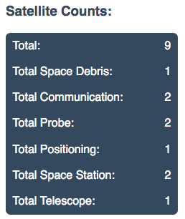

Example of the seven different satellite counts being displayed.

**Bonus Missions**

1. Search feature should also find matches using the orbitType and type properties.
2. Make every other row in the table have a background color.
3. For step 9, use an *ngFor to loop over an array of the different types, instead of explicitly writing a <tr> for each satellite type.
   * You may have already completed this mission, depending on how you accomplished step 9.

**Submitting Your Work**

In Canvas, open the Orbit Report assignment and click the "Submit" button. An input box will appear.

Copy the URL for your Github repository and paste it into the box, then click "Submit" again.

**Application Demo**